Minutes for Meeting 2, Friday 04/09/2015

Project Manager: Jeremy   
Present: Jeremy, Nabilah, Shu Wen, Zhi Hui, Darren  
Time of Meeting: 11:30am – 14:50pm

Pre-Agenda:

1. ERD
2. Set-up Environment
3. Functions into Schedule
4. SD for Bootstrap

Timeline of Meeting:

|  |  |  |  |
| --- | --- | --- | --- |
| S/N | Agenda (In details) | Brief Details: | Action By: |
| 1 | Planning of Schedule | Refer to the Schedule below. | All |
| 2 | ERD Drawing (Database) | Refer to Section 2 below.  Pair 1 (Darren and Shu Wen) to do further research on ERD Drawing | Pair 1 (After Meeting) |
| 3 | SD for BootStrap | Refer to Section 3 below.  Pair 2 (Nabilah and Zhi Hui) to do further work on the SD diagram | Pair 2 (After Meeting) |
| 4 | Update PP Log | Updated the PP Log with details for work (Points 2 and 3) for the week. | All |
| 5 | Agenda and Date of next Meeting | Refer to Point 1.   1. PM Changeover: Zhi Hui 2. Reassign Pair Teams 3. Pair 1 to show ERD Diagram work (Discussion) 4. Pair 2 to show SD Bootstrap   (Discussion)   1. Set up relations between Git and Netbeans (Action next week) 2. Begin Iteration 1: Week 4-5   (Time boxing, 2 weeks cycle)   1. Pair 1: Bootstrap Implementation 2. Pair 2: JSON Interaction 3. Prepare for Supervisor Meeting (Week 5)   Next Meeting Scheduled at 12/09/15, 1630 onwards. | Jeremy (PM) |

1. TIME SCHEDULE

|  |  |  |
| --- | --- | --- |
| Weeks: | Important Matters | Project Manager |
| 2 | Planning (Diagrams) – Use Case, Domain | Jeremy |
| 3 | Pair 1: [ERD]  Pair 2: [SD for bootstrap (as model)] |
| 4 | Pair 1: [Bootstrap]  Pair 2: [JSON Interaction] | Zhi Hui |
| 5 | Pair 1: [Bootstrap]  Pair 2: [JSON interaction] |
| 6 | Pair 1:[CRUD Location data]  Pair 2:[Login/Logout] [Generate Basic App Usage Report] | Nabilah |
| 7 | Pair 1:[CRUD Location data]  Pair 2:[Login/Logout] [Generate Basic App Usage Report]  *PM Review* |
| 8 | Pair 1:[Smartphone usage heatmap]  Pair 2:[Top-k usage report]  *-Break Week-* | Darren |
| 9 | Pair 1:[Smartphone usage heatmap]  Pair 2:[Smartphone overuse report] |
| 10 | Pair 1:[Social activity report]  Pair 2: [Integration crew] | Shu Wen |
| 11 | Pair 1:[Social activity report]  Pair 2: [Integration crew] |
| 12 | UAT | Jeremy |
| 13 | Sunday (End): Submission of SE Project |

1. ER DIAGRAMS

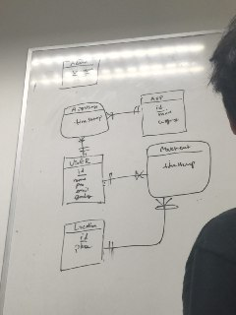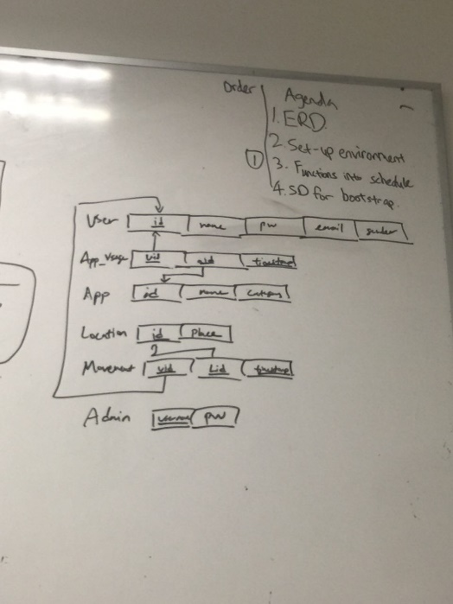

ER Diagram Logical Diagram

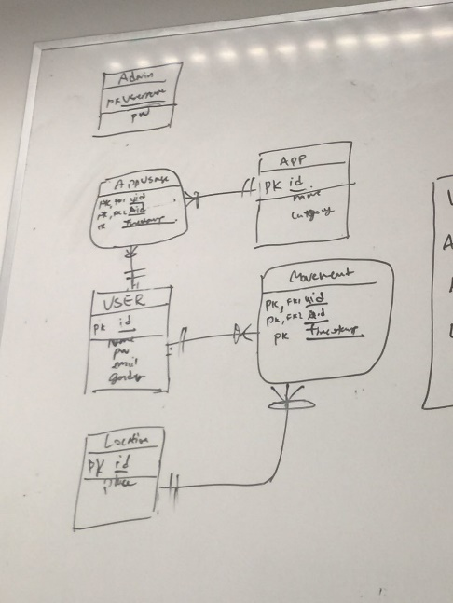

Our idea of the ERD

1. SD for Bootstrap

